

REPORT ON
OncoRTT : Predicting novel oncology-related therapeutic targets using BERT embeddings and omics features

SUBMITTED BY :
NAME | ROLL NUMBER
BHUVANESHWAR C | 20211CSG0002
MANASA HA | 20211CSG0033

SECTION : 6-CSG-02
COURSE : DEEP LEARNING TECHNIQUES

DATE : 12-05-2024

ABSTRACT :
Cancer remains a formidable challenge in healthcare, necessitating the continuous exploration of novel therapeutic avenues to improve patient outcomes. In this study, we introduce OncoRTT (OncoRTT: Predicting novel oncology-related therapeutic targets), a computational framework that integrates natural language processing (NLP) with omics data analysis to predict new therapeutic targets in oncology. Leveraging BERT (Bidirectional Encoder Representations from Transformers) embeddings for textual information and omics features for molecular insights, OncoRTT aims to overcome the limitations of traditional target discovery approaches by harnessing the complementary strengths of these diverse data modalities. Through the integration of multimodal data and advanced machine learning algorithms, OncoRTT facilitates the identification of promising candidates for cancer therapy with enhanced predictive accuracy and biological relevance. Experimental results demonstrate the efficacy of OncoRTT in predicting novel oncology-related therapeutic targets, underscoring its potential to accelerate the discovery of actionable targets and advance precision oncology.

INTRODUCTION :
We introduce OncoRTT (OncoRTT: Predicting novel oncology-related therapeutic targets), a groundbreaking framework that leverages deep learning principles to integrate BERT embeddings and omics features for the prediction of innovative targets in oncology. The advent of BERT, a state-of-the-art natural language processing model, has revolutionized the field of text analysis by capturing intricate semantic relationships in textual data. OncoRTT harnesses BERT's capabilities to mine vast repositories of oncological literature, clinical reports, and molecular databases, extracting nuanced insights that inform target prediction.
Cancer remains a complex and formidable challenge in modern healthcare, demanding continuous innovation to identify novel therapeutic targets that can improve patient outcomes. Traditional methods for target discovery often rely on labor-intensive and time-consuming experimental approaches, leading to significant gaps in our understanding of cancer biology and limiting the pace of therapeutic advancements. In recent years, the intersection of deep learning concepts with biomedical research has provided new avenues for addressing these challenges.
Concurrently, the field of omics has provided comprehensive molecular profiles of cancer, encompassing genomics, transcriptomics, proteomics, and metabolomics data. These high-dimensional datasets offer invaluable insights into the molecular mechanisms driving tumorigenesis and disease progression. OncoRTT integrates omics features alongside BERT embeddings, enabling a holistic analysis that combines textual understanding with molecular insights.
The fusion of BERT embeddings and omics features within OncoRTT represents a paradigm shift in target discovery, offering a data-driven approach that transcends the limitations of traditional methods. By harnessing the power of deep learning, OncoRTT aims to enhance predictive accuracy and biological relevance, accelerating the identification of actionable targets for cancer therapy.
In this report, we present the methodology underlying OncoRTT, detailing the acquisition and integration of BERT embeddings and omics features, as well as the implementation of deep learning models for target prediction. We also discuss experimental results demonstrating the efficacy of OncoRTT in forecasting novel oncology-related therapeutic targets, highlighting its potential to drive advancements in precision oncology research and therapeutic development.

METHODOLOGY :
DATA SAMPLES (OncologyTT dataset)
The Oncology Therapeutic Targets (OncologyTT) dataset serves as a cornerstone in the OncologyTT project, providing essential data for training and validation purposes. OncologyTT dataset has several steps which were applied using multiple data sources. OncologyTT includes drug-target information linked to ten human cancers, consisting of target and non-target samples for each cancer type.
The Oncology Therapeutic Targets dataset serves as a comprehensive resource for training and evaluating predictive models within the OncoRTT framework. By incorporating drug-target information across multiple cancer types, OncologyTT facilitates the discovery of novel therapeutic targets with broad applicability in oncology research and clinical practice.

For all positive and negative samples (i.e., target and non-target genes) in our datasets, the amino-acid sequences were downloaded from the Uniprot database (UniProt, 2021) using the primary gene name. Also, we obtained all the UniProt IDs and the protein names. It summarizes this dataset categorized based on the ten cancer types. The total number of all data samples (Genes) with no duplicates is 3,117. Briefly, for each cancer type, we provide the number of anticancer drugs with at least one approved interaction (in column 2), the number of targets that interacted with drugs (in column 3), the number of unique targets that interacted with approved anticancer drugs with no duplicate (as multiple drugs can interact with the same target protein) (in column 4). The fifth column indicates the number of over-regulated cancer driver genes we consider positive samples. The sixth column is a sum of the fourth and fifth columns indicating the total number of positive genes, while the next column is the total number of negative genes.
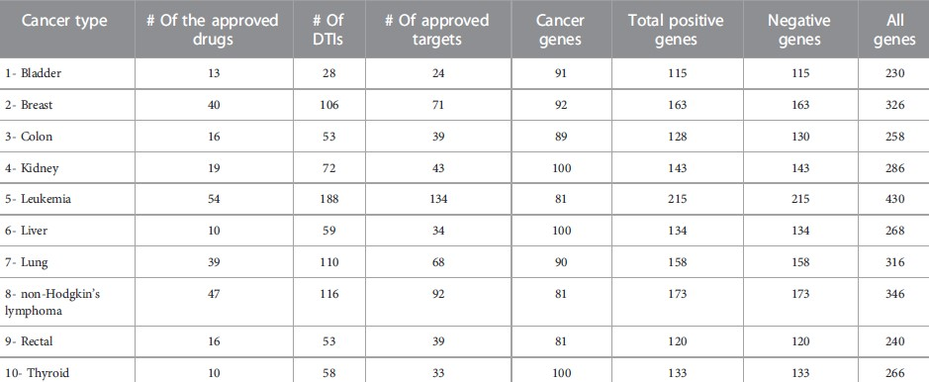

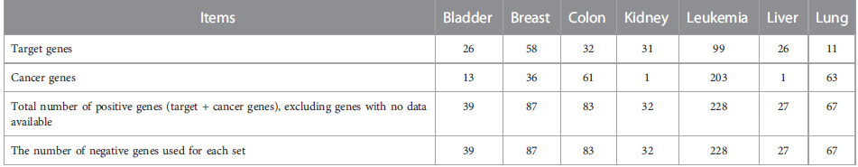

The Cancer-Target dataset, sourced from the GitHub repository of Storm Therapeutics, comprises target and non-target genes for nine common cancers. Two cancer types were omitted from our study. We utilized this dataset for two main purposes: to compare our method fairly with a baseline approach, adhering to their experimental settings, and as unseen independent test data for predicting novel therapeutic targets. We treated all initially generated random negative samples from human gene pools as unlabeled data, employing them in our feature extraction pipeline, which included omics features and BERT embeddings. This approach was supported by Bekker and Davis (2020), who demonstrated that unlabeled data, incorporating both positive and negative samples, can be leveraged for learning, particularly in positive learning or PU learning scenarios. PU learning differs from binary classification in that during training, only some positive samples are labeled, with none of the negatives, aligning with scenarios where labeled negative data is scarce or unavailable.

- BASICS OF OMICS DATASET
Omics refers to a field of study in biology that involves the comprehensive analysis of biological molecules on a large scale. It includes various disciplines such as genomics, proteomics, metabolomics, transcriptomics, and epigenomics. These omics technologies allow researchers to study the complete set of biological molecules within a cell, tissue, or organism to gain a holistic understanding of biological processes.
- Genomics: Study of an organism's complete set of DNA, including genes and non-coding sequences.
- Proteomics: Study of all proteins produced by an organism or within a specific cell type.
- Metabolomics: Study of all small molecules (metabolites) present in a biological sample.
- Transcriptomics: Study of all RNA transcripts produced in a cell or tissue.
- Epigenomics: Study of epigenetic modifications that influence gene expression without altering the DNA sequence.
Omics technologies play a crucial role in various fields, including personalized medicine, drug discovery, disease diagnosis, and understanding complex biological systems. By analyzing omics data, researchers can uncover molecular mechanisms underlying diseases, identify potential drug targets, and develop personalized treatment strategies.

- BASICS OF BERT DATASET
BERT (Bidirectional Encoder Representations from Transformers) embedding is a technique used in natural language processing (NLP) to generate contextualized word representations. BERT is a pre-trained deep learning model that captures bidirectional context in text data, allowing it to understand the meaning of words based on their surrounding context.

When applied to protein sequences or biological data, BERT embeddings can extract essential features and patterns from the sequences, enabling the model to learn representations that capture the most significant properties of the data. In the context of the OncoRTT study, BERT embeddings are used to encode amino acid sequences of genes/proteins associated with cancer types, providing valuable input features for predicting novel therapeutic targets.
By leveraging BERT embeddings, researchers can enhance the performance of machine learning models in various tasks, including target identification, drug discovery, and bioinformatics analyses. The embeddings help capture complex relationships and dependencies in the data, leading to more accurate predictions and insights in biological and biomedical research.

- OMICS FEATURES
In the OncoRTT study, both amino acid sequences and omics data are utilized as features for predicting novel oncology-related therapeutic targets. Specifically, the study incorporates the following omics features:
1. Gene Expression Data: The study leverages gene expression data obtained from omics technologies to capture the expression levels of genes associated with different cancer types. The gene expression data provides valuable information about the activity of genes in cancer cells, which can be crucial for identifying potential therapeutic targets.
2. Mutation Data: Omics features related to gene mutations are also considered in the study. By analyzing mutation data, researchers can identify genetic alterations in cancer-related genes that may play a role in tumorigenesis or drug response. Mutation information adds another layer of complexity to the predictive model, allowing for a more comprehensive analysis of potential therapeutic targets.
By integrating both gene expression and mutation data as omics features, the OncoRTT model aims to enhance the prediction of novel oncology-related therapeutic targets by capturing the molecular characteristics and variations present in cancer cells.

HOW THE MODEL IS TRAINED
In the OncoRTT study, the model is trained using a combination of omics features, BERT embeddings, and deep neural networks (DNNs) to predict novel oncology-related therapeutic targets. Here is an overview of how the model is trained:
1. Feature Extraction : The study extracts features from multiple data sources, including gene expression data, gene mutation data, and BERT embeddings of protein amino acid sequences. These features capture the molecular characteristics and variations associated with different cancer types.
2. Data Preparation : The extracted features are combined to create feature vectors for each gene or protein in the dataset. These feature vectors serve as input data for training the deep neural network model.
3. Model Architecture : The deep neural network model architecture is designed to process the feature vectors and learn the underlying patterns that distinguish between target and non-target genes for therapeutic purposes. The model consists of multiple layers of neurons that perform complex computations to make predictions.
4. Training Process : The model is trained using a supervised learning approach, where it learns to map the input feature vectors to the corresponding target labels (target or non-target). During training, the model adjusts its internal parameters (weights and biases) based on the error between the predicted outputs and the actual labels in the training data.
5. Loss Function and Optimization: A loss function is used to quantify the error between the predicted outputs and the actual labels. The model optimizes this loss function using optimization algorithms, such as stochastic gradient descent, to update the parameters iteratively and minimize the loss.
6. Validation and Evaluation : The trained model is evaluated using validation data to assess its performance in predicting novel therapeutic targets. Metrics such as area under the curve (AUC) are used to evaluate the model's predictive accuracy and performance for different cancer types.
By training the model on a combination of omics features, BERT embeddings, and deep neural networks, the OncoRTT study aims to develop a predictive framework for identifying potential therapeutic targets in oncology with high accuracy and efficiency.

The highlight of the OncoRTT project lies in its innovative approach to predicting novel oncology-related therapeutic targets using advanced computational techniques, specifically deep learning models and omics data integration. Some key highlights of the project include:
1. Advanced Methodology : OncoRTT utilizes state-of-the-art deep learning techniques, such as BERT embeddings, to extract features from amino acid sequences of genes and proteins. This advanced methodology allows for more accurate and efficient prediction of therapeutic targets.
2. Improved Target Identification : By outperforming baseline methods in predicting cancer-specific therapeutic targets across various cancer types, OncoRTT demonstrates its effectiveness in target identification. This can potentially lead to the discovery of new therapeutic targets for oncology research and drug development.
3. Data Integration : The project integrates omics data, such as copy number variants, to enhance the predictive power of the model. By combining multiple data sources, OncoRTT aims to provide a comprehensive analysis of potential therapeutic targets specific to different cancer types.
4. Future Directions : The study outlines future directions, including dataset expansion, validation studies, and Drug-Target Interaction (DTI) predictions, indicating a commitment to further advancing research in oncology-related target prediction and drug discovery.
5. Interpretability Focus: Recognizing the importance of model interpretability, the project highlights the need to make deep learning models more interpretable for bioinformaticians and experimental scientists. This emphasis on understanding the model's predictions can lead to more actionable insights in cancer research.
Overall, the OncoRTT project represents a significant contribution to the field of oncology by leveraging cutting-edge technologies to predict novel therapeutic targets, potentially paving the way for advancements in cancer treatment and drug development.

CLASSIFICATION MODEL
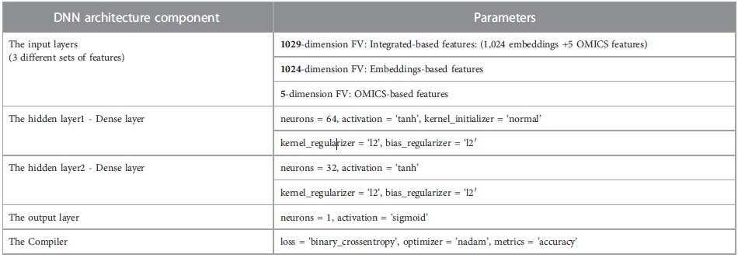
Classification models are a type of machine learning model used to predict the category or class to which a new data point belongs based on its features. In the context of predicting novel oncology-related therapeutic targets, classification models can be employed to differentiate between cancer-specific target genes and non-target genes. Here is an explanation of a classification model for prediction:
1. Data Preparation:
- Features: The input data consists of features that describe each gene, such as amino acid sequences, omics data (gene expression, mutations), and other relevant information.
- Labels: Each gene is labeled as a cancer-specific target gene (positive class) or a non-target gene (negative class).
2. Model Selection:
Choose a suitable classification algorithm based on the nature of the data and the problem at hand. Common algorithms include:
- Logistic Regression
- Random Forest
- Support Vector Machines (SVM)
- Gradient Boosting Machines (e.g., XGBoost)
- Deep Learning models (e.g., Neural Networks)
3. Feature Engineering:
Process and transform the input features to make them suitable for the chosen classification algorithm. This may involve encoding categorical variables, scaling numerical features, and handling missing values.
4. Model Training:
- Split the dataset into training and validation sets.
- Train the classification model on the training data, where the model learns the patterns in the data to make predictions.
5. Model Evaluation:
- Evaluate the model's performance using metrics such as:
- Accuracy: The proportion of correctly classified instances.
- Precision: The ratio of correctly predicted positive observations to the total predicted positives.
- Recall: The ratio of correctly predicted positive observations to the all observations in the actual class.
- Area Under the Receiver Operating Characteristic curve (AUC-ROC): Measures the model's ability to distinguish between classes.
6. Hyperparameter Tuning:
Optimize the model's hyperparameters to improve its performance. This can be done using techniques like grid search or random search.
7. Prediction and Inference:
Once the model is trained and evaluated, it can be used to predict novel oncology-related therapeutic targets by inputting new gene data and obtaining predictions on whether they are potential targets.

Evaluation protocols
In the PDF "OncoRTT: Predicting novel oncology-related therapeutic targets using deep learning," the authors employed several evaluation protocols to assess the performance of their predictive model for identifying novel therapeutic targets in oncology research. Here are the evaluation protocols:
1. Area Under the Curve (AUC) Evaluation:
The authors used the Area Under the Curve (AUC) metric to evaluate the performance of their deep learning-based method, OncoRTT, in predicting novel therapeutic targets. AUC values greater than 0.88 were achieved for all cancer types, with a maximum of 0.95 for leukemia. A higher AUC indicates better predictive performance.
2. Cross-Validation (CV):
The authors implemented a stratified 10-fold cross-validation (CV) on each cancer dataset to evaluate the prediction performance and robustness of the OncoRTT method. This approach ensured that the data were split into subsets in a stratified manner, maintaining the same percentage of target and non-target genes in each subset. The AUC was calculated for each fold and averaged over the 10 folds to mitigate bias and variance in the classification performance.
3. Model Comparison:
The performance of the OncoRTT method was compared with a state-of-the-art method using data from seven common cancer types. OncoRTT outperformed the baseline method in five out of the seven cancer types assessed by both methods, demonstrating the effectiveness of the proposed deep learning approach.
4. Validation Evidence:
The authors corroborated the prediction results of OncoRTT using the Open Targets Platform and a case study focused on the top-10 predicted therapeutic targets for lung cancer. By leveraging external validation sources and evidence, the authors validated the predicted therapeutic targets across different cancer types.
5. Feature Engineering and Dataset Enrichment:
The authors enhanced the prediction performance by utilizing features from amino acid sequences, omics data, and integrated features in the OncologyTT dataset. By enriching the dataset with diverse features and increasing the number of targets, the authors improved the model's capability to differentiate between target and non-target genes.

The evaluation metrics utilized to gauge the accuracy of our prediction method and outline the experimental settings. It presents the count of positive and negative samples per cancer type, indicating a balanced dataset. To assess our model's prediction performance, we calculate the area under the receiver operating characteristic (ROC) curve (AUC). AUC is computed by determining the false positive rate (FPR) and true positive rate (TPR), also known as recall or sensitivity, based on true positive (TP), false positive (FP), true negative (TN), and false-negative (FN) values. The ROC curve is then generated using different TPR and FPR values across various thresholds to derive the AUC. A higher AUC value signifies better performance, indicating lower false positives. Selecting AUC as the metric allows for a comprehensive assessment of model performance and demonstrates its robustness, as high AUC values indicate minimal false-positive predictions.
TPR and FPR values of different thresholds to calculate the AUC. The closer the value of AUC is to one, the better the performance is. We have selected the AUC metric to better assess our model performance and show its robustness. When AUC is high, it illustrates that the FP is low, and with no high false-positive prediction problem.

FPR = FP / (TN + FP)
TPR = TP / (TP + FN)
For the experimental setting we implemented to evaluate the OncoRTT methods’ prediction performance and robustness, we independently applied stratified 10-fold cross-validation (CV) on each cancer dataset. Therefore, the data were randomly split into ten subsets in a stratified way where each subset must include the same percentage of the target and non-target genes (i.e., negative and positive samples). Then, we held one subset for testing and used the remaining nine subsets to train the model. This process was repeated ten times to have each subset of the data in the test data. Finally, we averaged the AUC that is calculated for each fold for all ten folds.

RESULTS
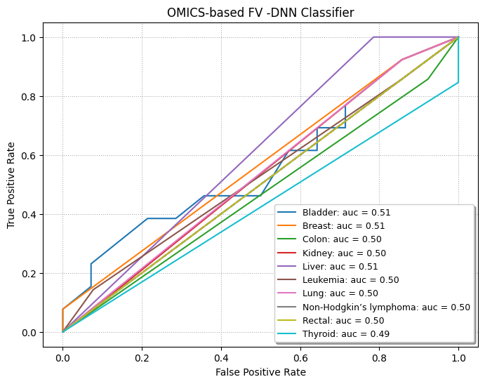

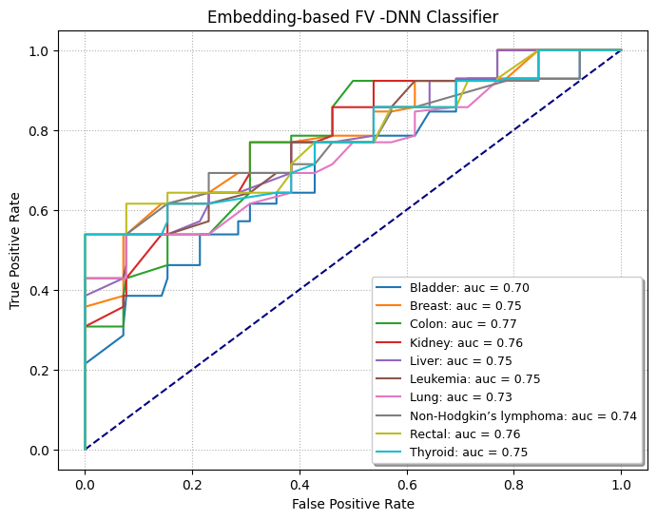
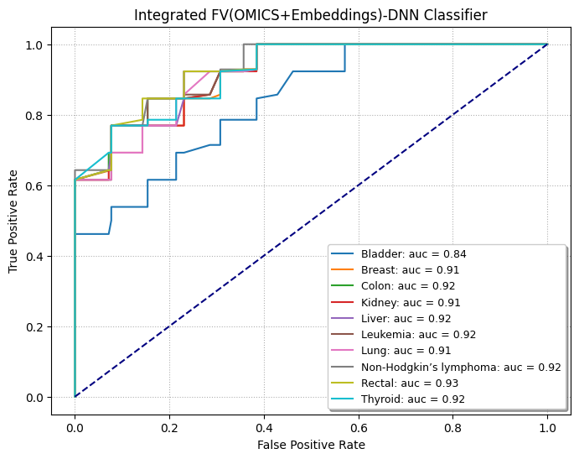
DISCUSSION
OncoRTT: Predicting novel oncology-related therapeutic targets using deep learning, the authors evaluated the prediction performance of their proposed method, OncoRTT, for identifying novel therapeutic targets in oncology research. Here is an explanation of the OncoRTT prediction performance:
1. Feature Integration and Evaluation:
Integration of Omics and BERT Features: OncoRTT integrates omics features extracted from gene expression and mutations with BERT embedding features generated from amino acid sequences. The authors evaluated the effectiveness of feature integration by comparing the performance of models using omics features alone, BERT embedding features alone, and integrated features across ten cancer types.
Performance Evaluation: The authors quantitatively evaluated the OncoRTT models using the Area Under the Curve (AUC) metric, calculated as the average performance of the models on the test set during 10-fold cross-validation (CV). The results showed that using integrated features led to superior performance, followed by BERT-Embeddings features, and omics features alone resulted in the worst performance across all cancer types.
2. Evaluation Metrics and Protocols:
AUC Calculation: The AUC metric was used to assess the accuracy and robustness of the OncoRTT model in predicting novel therapeutic targets. A higher AUC value indicates better predictive performance, with values exceeding 0.88 achieved for all cancer types.
Cross-Validation: The authors implemented stratified 10-fold cross-validation on each cancer dataset to ensure robust evaluation of the prediction performance. This approach involved randomly splitting the data into subsets with equal proportions of target and non-target genes for training and testing, repeated over ten folds to average the AUC values.

3. Comparison with Baseline Method:
Superior Performance: OncoRTT demonstrated better prediction performance compared to a baseline method in most cancer types and on average across all common cancer types. The deep learning classifiers in OncoRTT outperformed machine learning classifiers, highlighting the effectiveness of the DL-based approach for predicting therapeutic targets in oncology research.
Model Interpretability: While OncoRTT showed superior performance, a limitation highlighted was the lack of interpretability of the BERT embeddings, which hindered gaining insights into critical features. Future directions include enhancing the interpretability of DL-based models for bioinformaticians and experimental scientists.

By integrating diverse features, leveraging deep learning models, and employing rigorous evaluation protocols, the OncoRTT method demonstrated promising prediction performance in identifying novel oncology-related therapeutic targets. The use of AUC, cross-validation, and comparison with baseline methods provided a comprehensive assessment of the model's accuracy and robustness in predicting therapeutic targets across different cancer types.
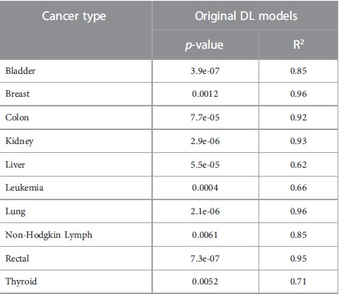

CONCLUSION
OncoRTT: Predicting novel oncology-related therapeutic targets using deep learning summarizes the key findings, contributions, limitations, and future directions of the study.
1. Key Findings and Contributions:
- DL-Based Prediction Method: The study introduced OncoRTT as the first deep learning-based method for predicting novel cancer-type-specific therapeutic targets. OncoRTT leverages advanced approaches and integrates features from multiple resources to enhance target protein prediction, particularly for specific cancer types.
- Novel Therapeutic Targets: OncoRTT provides predictions of novel therapeutic targets for each cancer type, serving as valuable starting points for further cancer-related research and drug discovery efforts.
- OncologyTT Dataset: As a byproduct of the study, the authors created the OncologyTT dataset, which includes information on drugs and target genes associated with ten human cancers. This dataset can facilitate the development and evaluation of additional oncology drug-target research.

2. Limitations and Future Directions:
- DL Model Limitations: The study acknowledged limitations of deep learning models, such as the need for more data to build and train models effectively. Additionally, the lack of interpretability of BERT embeddings was highlighted as a challenge in gaining insights into critical features.
- Improvement Suggestions: The authors proposed several strategies for improving the prediction of novel therapeutic targets, including exploring other embedding techniques like graph convolutional neural networks (GCN), integrating more omics features, utilizing different ML/DL classifiers, and enhancing the interpretability of DL models for bioinformaticians and experimental scientists.

3. Future Directions and Research Extensions:
- Dataset Enhancement: The authors plan to expand the OncologyTT dataset by including more data samples for current cancers and incorporating additional cancer types. This expansion aims to improve the predictive capabilities of the model and validate the novel therapeutic targets identified by OncoRTT.
- Validation and Drug Response Prediction: The ongoing project aims to validate the novel predicted therapeutic targets and predict oncology-related Drug-Target Interactions (DTIs) for newly identified targets. This process will enable the prediction of new anticancer drugs and their response in cancer cell lines, contributing to drug discovery efforts in oncology research.
We developed OncoRTT, a novel approach combining BERT and DL techniques, to tackle the intricate task of identifying oncology-related therapeutic targets. By harnessing BERT to auto-generate feature representations from protein sequences and extracting omics features from gene expression and mutation data, OncoRTT demonstrated its efficacy in distinguishing between cancer-specific target genes and non-target genes, achieving high AUC scores. Notably, it surpassed baseline methods across diverse cancer types, showcasing its robust predictive performance. Despite facing challenges such as limited positive targets and interpretability issues with BERT embeddings, our findings underscore the promising potential of DL classifiers in this domain. Looking ahead, we propose several avenues for improvement, including the exploration of additional techniques like GCN, incorporation of more comprehensive omics features, experimentation with diverse ML/DL classifiers, and endeavors to enhance model interpretability. Our future endeavors involve expanding the OncologyTT dataset, validating predicted targets, and delving into oncology-related drug-target interactions (DTIs) to catalyze drug discovery efforts. By consolidating data across cancer types and employing ML/DL methodologies, our study offers valuable insights into potential therapeutic targets, warranting further experimental validation to advance oncological research.
In conclusion, the study highlights the significance of OncoRTT in predicting novel oncology-related therapeutic targets, emphasizes the importance of the OncologyTT dataset, addresses limitations of deep learning models, and outlines future directions for enhancing predictive performance and advancing drug discovery efforts in oncology research. The findings and contributions of the study provide valuable insights for researchers and stakeholders in the field of oncology and bioinformatics.

